**Power Analysis**



**Model Design:**

**Treatment Structure:** A 2×2 factorial arrangement involving:

Factor 1: Inoculation Method (Dry, Wet)

Factor 2: Thickness (1/4-inch, 1/8-inch) Plus, repeated measures over Time (Week 1 to Week 5).

**Design Structure:** Likely a randomized complete block design (RCBD), where: Blocks (Batches) are a random effect. Treatments are combinations of the Inoculation Method and Thickness, with measurements taken over time.

𝑦𝑖𝑗𝑘𝑙 = 𝜇 + 𝛼𝑖 + 𝛽𝑗 + (𝛼𝛽)𝑖𝑗 + 𝛾𝑘 + 𝛿𝑙 + 𝜖𝑖𝑗𝑘𝑙

* The inoculation method effect is represented by 𝛼𝑖 (𝑖 = 𝑑𝑟𝑦, 𝑤𝑒𝑡).
* The thickness effect is represented by 𝛽𝑗 (𝑗 =  𝑜𝑟  𝑖𝑛𝑐ℎ𝑒𝑠).
* The week effect is represented by 𝛾𝑘 (𝑘 = 1, … ,5).
* The blocking effect is represented by 𝛿𝑙.

The client is interested to see “*whether the wet inoculation method and 1/4-inch thickness would yield a lower reduction in Bacteria after drying*”

SAS Code

**data** rptm_means;

input Inoculation_Method $ Thickness $ @@;

do Week=**1** to **5** by **1**; input mu @@; output;

end; datalines;

Dry 1/4 4.26 4.25 4.47 4.33 4.54

Dry 1/8 4.91 4.95 4.67 4.56 4.97

Wet 1/4 4.21 4.57 4.65 4.49 4.38

Wet 1/8 4.86 4.78 4.62 4.32 4.22

;



**data** rptm_design; set rptm_means;

do Batches = **1** to **5**; /* Creating 5 blocks (batches) */

output; end; **run**;



**proc** **print** data=rptm_design;

**run**;

/* Creating Model */ **proc** **glimmix** data=rptm_design; 

class Batches Inoculation_Method Thickness Week; model mu = Inoculation_Method|Thickness|Week;

random intercept / subject=Batches;

random Week / subject=Batches*Inoculation_Method*Thickness type=ar(**1**) residual; parms (**.029**)(**0.017**)(**.028**)/hold=**1**,**2**,**3**; /* Provide 3 parameters for variance components */

lsmeans Inoculation_Method*Thickness*Week / slicediff=Week cl;

/* Define main effect contrasts */

contrast 'Dry vs Wet'

Inoculation_Method **1** -**1**; contrast '1/4 vs 1/8 inches'

Thickness **1** -**1**;

/* Define interaction contrasts */ contrast 'Dry vs Wet at 1/4 Inches'

Inoculation_Method **1** -**1** Inoculation_Method*Thickness **1** **0** -**1** **0**;

contrast 'Dry vs Wet at 1/8 Inches'

Inoculation_Method **1** -**1** Inoculation_Method*Thickness **0** **1** **0** -**1**;

contrast '1/4 vs 1/8 inches for Dry inoculation'

Thickness **1** -**1** Inoculation_Method*Thickness **1** -**1** **0** **0**;

contrast '1/4 vs 1/8 inches for Wet inoculation'

Thickness **1** -**1** Inoculation_Method*Thickness **0** **0** **1** -**1**;

ods output contrasts=f_contrast tests3=f_anova;

**run**;

/*Power*/ **data** 

power;

set f_contrast f_anova;

ncparm = numdf * fvalue;

alpha = **0.05**;

fcrit = finv(**1**-alpha, numdf, dendf, **0**); power = **1** - probf(fcrit, numdf, dendf, ncparm);

**run**;



**proc** **print** data=power;

**run**;

**Output:**

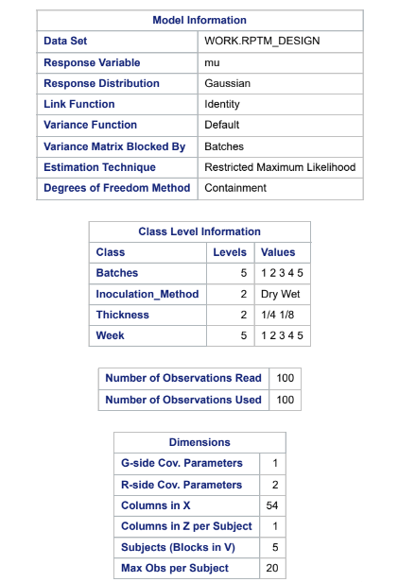

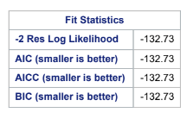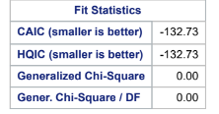

The Fit Statistics Model here indicates a strong performance. The -2 Res Log Likelihood value of -132.73 suggests a good fit to the data. Given that the AIC, AICC, BIC, CAIC, and HQIC are all equal to -132.73, lower values indicate a better model fit. The Generalized Chi-Square and the Generalized Chi-Square to degrees of freedom equals 0, suggesting that there is no overdispersion. From these fit statistics, we can see that the model fits the data well.

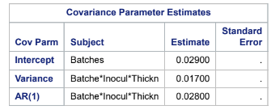

The intercept for the batches is estimated at 0.029, suggesting a baseline level of variance within the study. The variance associated with the interaction between batches, inoculation method, and thickness is 0.017 respectively, indicating some degree of variability. The AR (1) parameter for the interaction between batches, inoculation method, and thickness is estimated at 0.028.

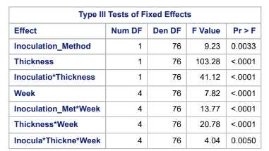

The Inoculation_Method variable yields an F Value of 9.23 and a p-value of 0.0033, which indicates a significant difference between the inoculation methods (dry vs. wet). The thickness variable also yields significant results, and like the inoculation method, it can be seen that there is a significant difference between ¼ inch and ⅛ inch. The interaction between inoculation and thickness is also significant, indicating that the effect of the inoculation method varies depending on the thickness. With significant results from the Week Main effect, there is evidence to suggest that the response variable changes significantly over time. The interactions of the inoculation method with week and thickness with week are both significant, indicating that the effects of inoculation and thickness are dependent on the week. Finally, the three-way interaction among the inoculation method, thickness, and week suggests that the combined effects of these factors are also significant.

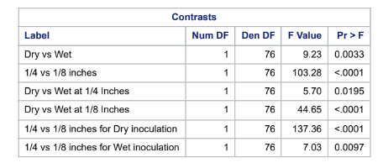

The contrast table shows the comparison of various conditions on the response variable. As the table says, each contrast yields a statistically significant result. The ¼ vs ⅛ inches and ¼ vs ⅛ inches for Dry inoculation yield especially high F values, indicating a strong effect of thickness on the response. The table highlights the significant effect that both the inoculation method and thickness have on the response variable throughout the study.

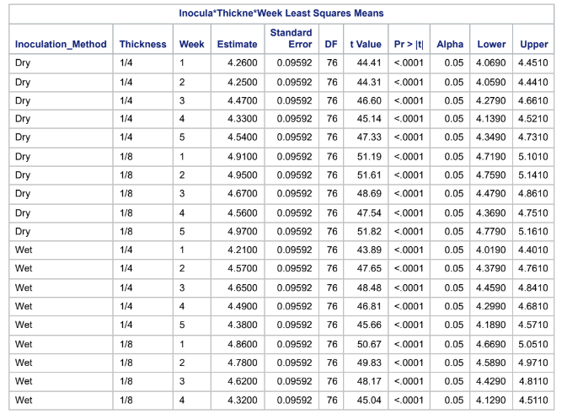

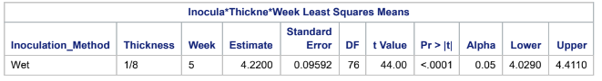

The Least Squares Means for interaction table here provide detailed estimates of the levels of Salmonella across the given conditions. For the Dry inoculation method at a thickness of 1/4 inch, the estimates across the five weeks range from 4.2600 to 4.5400, with all t values exceeding 44 and p-values less than 0.0001, indicating highly significant effects across weeks. For the Dry method at 1/8 inch, the estimates are notably higher, ranging from 4.6700 to 4.9700 across the weeks, with similarly significant values. The Wet inoculation at both thicknesses also reveal significant results. The standard error being approximately 0.09592 suggests reliable estimates and narrow confidence intervals. These narrow intervals and low variability helps further reinforce the precision of these estimates.

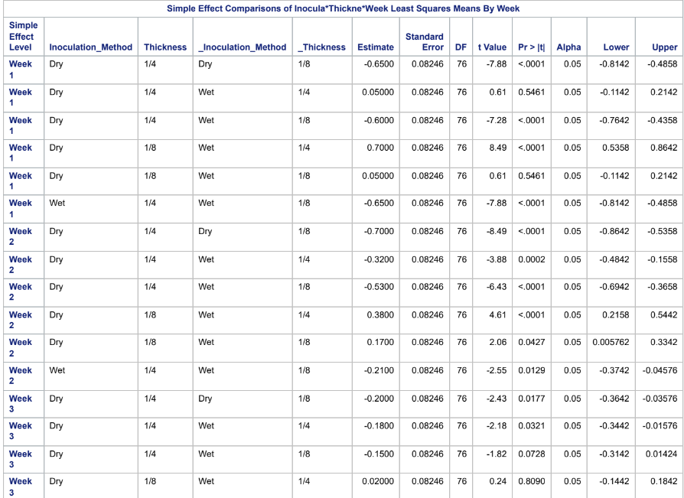

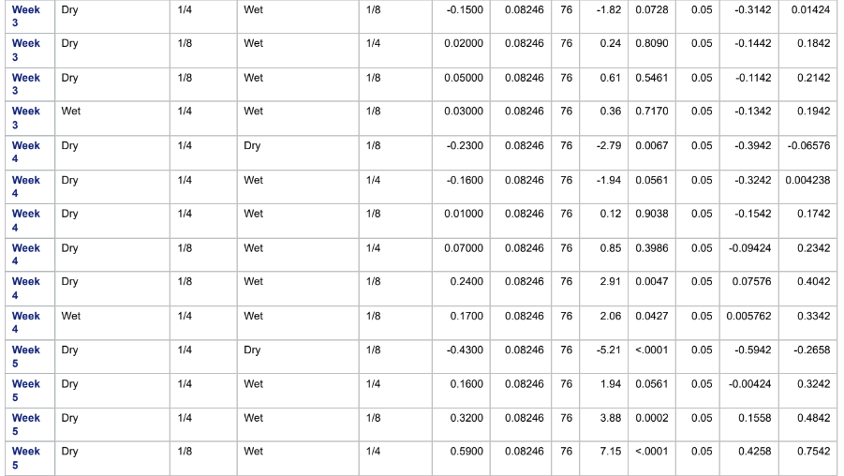

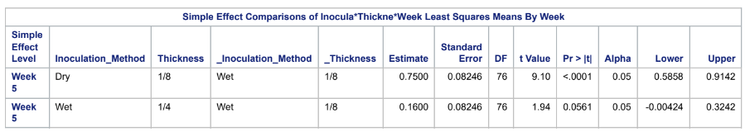

The simple effect comparisons for the interactions between thickness, inoculation method, and week show the results on the response variable, especially shown in week 5. The results show that the most significant results are shown in the Dry inoculation method, as well as the thinner thickness of ⅛ inch. Especially in week 5, these results are shown. Given this table, there is evidence to suggest the most significant results come from the Dry inoculation method at ⅛ inch thickness.

***Power Table:***

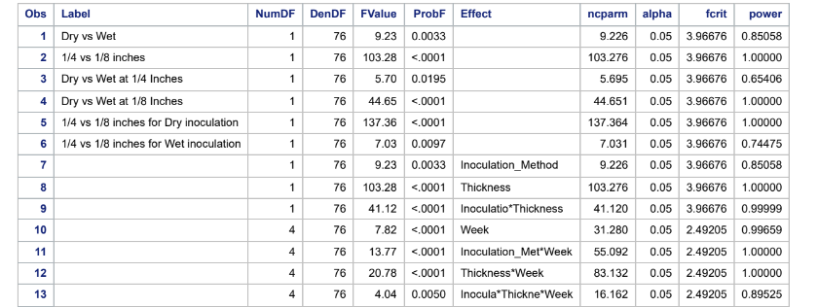

The analysis reveals significant effects and interactions among the variables tested.

* The inoculation method (Dry vs. Wet) has an F value of 9.23 and a p-value of 0.0033, indicating a strong difference between the methods, with the power showing an 85% chance of detecting this difference.
* Thickness comparisons (1/4 vs. 1/8 inches) show an even stronger effect, with an F value of 103.28 (p < 0.0001) and 100% power, showing the test is highly likely to detect any real difference.
* The interaction between the inoculation method and thickness is also highly significant (F = 41.12, p < 0.0001) with nearly 100% power, suggesting that the effect of the inoculation method varies by thickness. Week-to-week changes are significant as well (F = 7.82, p < 0.0001) with 99.7% power, indicating temporal effects on the response.

*The specific contrasts reinforce these findings:* The Dry vs. Wet comparison and the thickness difference are significant (F values of 9.23 and 103.28). At the 1/4-inch thickness, the effect of the inoculation method is significant (F = 5.70, p = 0.0195) with 65.4% power, while at 1/8 inches, the difference is highly significant (F = 44.65, p < 0.0001) with full power. For Dry inoculation, the thickness comparison is exceptionally strong (F = 137.36, p < 0.0001) with high power, while Wet inoculation shows a significant but slightly lower effect (F = 7.03, p = 0.0097, 74.5% power).

**Summary of Results**

The results from the SAS code suggest both the inoculation method (dry vs wet) and the thickness (¼ and ⅛ inch) have a significant effect on the response variable. There are many significant interactions, and we can see that the effect of the inoculation method depends on thickness, both factors show interactions with Week, showing that their effects vary over time. Most of the effects have a strong power, either close to or at 100%. With those values, there is confidence in detecting differences. The lower powered contrast (i.e. Dry vs. Wet at ¼ inches) could still be reliable, but since they are lower, they could benefit from more data to ensure more stable conditions.